**Facebook has committed to using 100% renewable power for g global operations by 2020**

**ADM 6277 E-Business Energy Management**

Submitted to

Professor Omer Livarccin

Submitted by

Juveriya Zameer [300116986]

***Abstract***

|  |
| --- |
| Companies like Facebook and other Tech companies are continuously under pressure to manage energy for data centers by adding renewable sources of energy. According to the recent market report from Transparency Market Research (TMR) – Facebook is not the only one stepping up to the challenge [1].The market firm also pointed out that Facebook competitors companies, for instance Apple, in 2013 has achieved its goal of having 100% renewable energy for all of its data centers through a combination of solar and wind power. In addition, Big companies like IBM, GOOGLE are continuously striving towards achieving renewable energy as a higher percentage in their energy grid.  Facebook has inked its first renewable energy deal in 2013, since then Facebook has signed contracts for over 3 gigawatts of new solar and wind energy, the company says.[7] “Facebook try to make sure that all of its wind and solar projects are new and on the same grid as their data centers,” the announcement claims. “That means that each of these projects brings jobs, investment and a healthier environment to the communities”[1].Earlier in 2018, The company fulfilled a promise of reaching 51% clean and renewable energy in 2017. In 2018, facebook has further committed to reducing greenhouse gas emissions by 75% and powering its global operations with 100% renewable energy by the end of 2020. |

***Introduction***

In a record-breaking year of corporate renewable energy purchases, Facebook is on track to be one of the largest corporate purchasers of renewable energy. Since their first purchase of wind power in 2013, Facebook has signed contracts for over 3 gigawatts of new solar and wind energy that includes over 2,500 megawatts in just the past 12 months. What’s especially good about the Facebook renewable purchases is that they’re not just offset agreements — deals where a company buys renewable energy in some far-flung geography to offset the power they’re buying in local markets that relies on traditional carbon-based fuel sources.

“All of these wind and solar projects are new and on the same grid as our data centers,” the company said. “That means that each of these projects brings jobs, investment and a healthier environment to the communities — from Prineville, Oregon, and Los Lunas, New Mexico, to Henrico, Virginia, and Luleå, Sweden.”[2]

***Sustainability Initiatives***

Data centers power the internet and make it possible to connect with the communities that are central to our lives. Facebook has design, Build and operated some of the most sustainable data centers in the world. Efficiency and clean energy are key components of Facebook’s strategy to design, build and operate sustainable data centers. Facebook is making their data centers energy efficient through innovative design with its hyper-efficient Open Compute Project servers can operate in a higher-temperature environment than traditional equipment [3]. This lowers the amount of energy needed to keep the servers cool and makes it possible for Facebook data centers to use outdoor air for cooling instead of energy-intensive air-conditioning units. It is also expanding its sustainability toolkit with machine learning. As part of this effort, Facebook has developed a machine learning model that helps to monitor, predict, and optimize the efficiency of the data center operations. The model takes in and evaluates several key inputs, including seasonality, weather, and IT capacity. These values are updated by the minute and the model then compares the current data to historical information about the building’s operations. Using these datasets, the model provides an accurate gauge of how well their systems are performing. In 2020, it will have committed to enough new renewable energy resources to match 100% of the energy used by every data center built by Facebook, and always in the same state or power grid as the data center itself. In 2018, we doubled our corporate renewable energy procurement from 2017, adding over 2.6 gigawatts which accounted for approximately 20% of the global corporate renewable energy volume. These data centers are currently supporting nearly 1 gigawatt of operating renewable energy projects. Often, by creating new energy tariffs in collaboration with local utilities and others, Facebook make it possible for other businesses to purchase more clean energy as well. *The company aim to use more renewable energy and make it a higher percentage of energy mix. In 2018, they achieved 75% renewable energy for their operations.*[4]

Facebook has prioritized water stewardship across everyday operations and they are proud to say that its data centers are among the most efficient in the world. In these data centers, to keep servers cool in locations with environmental challenges — like high levels of dust, extreme humidity, they use indirect evaporative cooling in conditions like this and have been working with partners to make this technology even more efficient. In partnership with Nortek Air Solutions, they’ve developed the StatePoint Liquid Cooling (SPLC) system, which is an advanced evaporative cooling technology that uses cold water instead of cold air [3]. This is the first time that technology of this kind will be applied to data centers, and it allows us to build highly water-efficient data centers where direct cooling is not possible. They also have invested in circular systems that reuse water as many times as possible before releasing it to wastewater treatment plant. Due to highly efficient cooling designs, the data centers are 80% more water efficient than average. In 2018 alone, it saved 5.7 billion liters (1.5 billion gallons) of water worldwide – the equivalent of filling 18.5 million bathtubs of water.[3]

Also, Facebook uses Power Usage Effectiveness (PUE) to measure how efficiently its data centers convert energy into compute power.PUE is how we measure the operating efficiency of its data centers. It compares the total amount of power sourced from utility with the power used to run the hardware within the data center. The “ideal” PUE is 1.0, meaning that every electron entering the site is used to power the hardware inside the data center. The industry average PUE is 1.5, and Facebook is proud because its facilities have averaged 1.11 or below for the last five years and they are still continue to look for additional ways to get even closer to 1.0.[4] Table 2

***Benefits***

Beyond helping Facebook reduce emissions and fight climate change, a major benefit of sustainability initiative is the job creation and economic development associated with building new renewable energy projects. Because of focus on building new renewable energy projects in the same state or on the same electrical grid where data centers are located, there are many additional construction and operations jobs being created in those regions. For example, in New Mexico, Facebook has signed contracts for six new projects that will result in 1,300 jobs throughout the state.[5]

***Challenges***

One of our biggest challenges has been the nature of the energy sector in general. Electric utilities' traditional business model hasn't typically allowed customers to pick where their energy comes from. The Facebook team pulled upon its collective experience to help show how utility companies can enable customers to choose renewable energy without increasing costs to others. Adding renewable energy can often reduce these costs, actually. We seek out utilities who want to work with their customers and design new options for the 21st century that will help to increase adoption of renewable energy and reduce fossil fuel reliance. Facebook has led the charge to change the approach to renewable energy in over a dozen states, working with utility partners to design and adopt new choices for renewable energy for their customers.[5]

***Conclusion***

The targets that Facebook is making public today are part of the company’s commitment to the Paris Agreement through the “We Are Still In” initiative, the company said. For Facebook, the announcement is something of a victory lap. Back in 2015, the company set a goal of having 50 percent of its power supplied to facilities from renewable energy sources by 2018. It actually hit that target in 2017 and on the right track to achieved 100 % renewable energy by 2020.

Corporate renewable procurements serve many interests. They bring clean generation online and they offer utilities a rare source of load growth. The pronounced increase in these deals testifies to the number of companies that now consider renewables a cost-effective investment.[6]

**References**

[1][1] “Facebook On Track to Become ‘Largest Corporate Purchaser’ of Renewable Energy.” [Online]. Available: https://www.environmentalleader.com/2018/08/facebook-on-track-to-become-largest-corporate-purchaser-of-renewable-energy/. [Accessed: 22-Feb-2020].

[2] “Facebook has committed to using 100% renewable power for global operations by 2020 | TechCrunch.” [Online]. Available: https://techcrunch.com/2018/08/28/facebook-has-committed-to-using-100-renewable-power-for-global-operations-by-2020/. [Accessed: 22-Feb-2020].

[3] “Sustainable data centers – Facebook Sustainability.” [Online]. Available: https://sustainability.fb.com/innovation-for-our-world/sustainable-data-centers/#section-Water. [Accessed: 22-Feb-2020].

[4] “Sustainability in numbers – Facebook Sustainability.” [Online]. Available: https://sustainability.fb.com/sustainability-in-numbers/. [Accessed: 22-Feb-2020].

[5] “Q&A: Facebook reaches 75% renewable energy.” [Online]. Available: https://tech.fb.com/facebook-reaches-75-renewable-energy/. [Accessed: 22-Feb-2020].

[6] “Is Facebook Powered by 100% Renewable Energy? | Greentech Media.” [Online]. Available: https://www.greentechmedia.com/articles/read/facebook-pledges-to-buy-100-renewable-energy-by-2020. [Accessed: 22-Feb-2020].

[7] “Facebook vows to run on 100 percent renewable energy by 2020 - The Verge.” [Online]. Available: https://www.theverge.com/2018/8/28/17790806/facebook-renewable-energy-climate-change-greenhouse-gas-2020. [Accessed: 22-Feb-2020].

**Appendices**

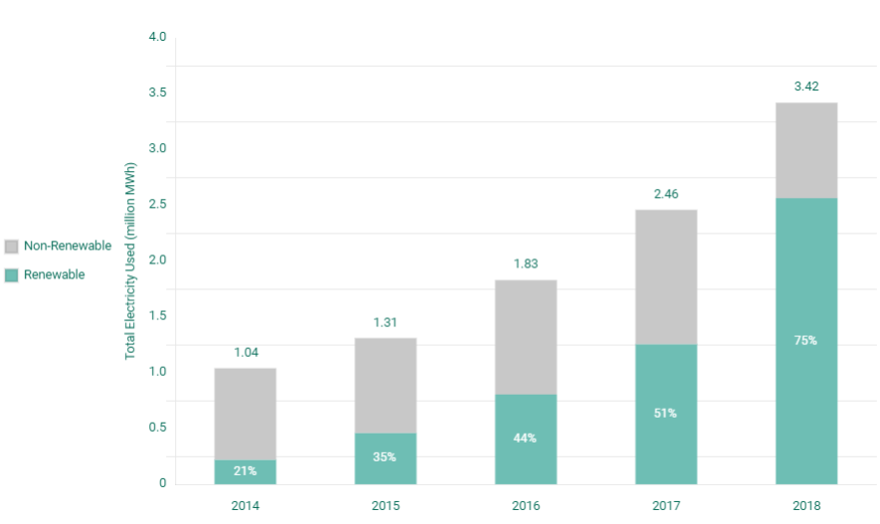

Table 1 : ELECTRICITY MIX

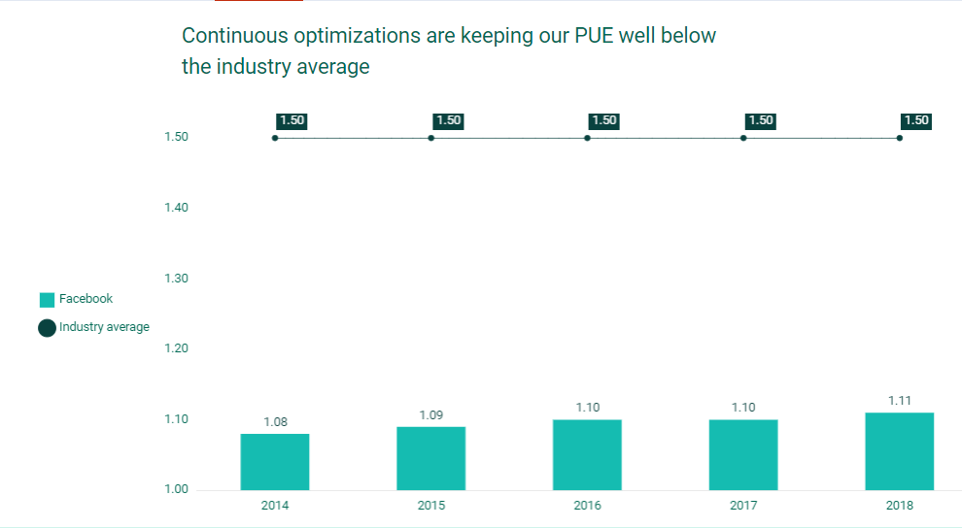

Table 2: PUE across Data centers from 2014- 2018